**Exercise 2. Data-rich methods (Arctic Sardine MU1)**

|  |
| --- |
| **Exercise Goal:** Identify ways to define an LRP for Arctic Sardine MU1 in a data-rich context. |

|  |
| --- |
| **Exercise Activity:**   1. Evaluate at least 3 approaches to defining an LRP for Arctic Sardine MU. Identify the “preferred” approach 2. As a group, complete the slides in the Powerpoint File. The last slide will be presented by a group member at the beginning of the workshop tomorrow. Explain: 3. **Candidate approaches** considered, and their pros/cons 4. The **preferred approach** and **rationale** for choosing both the indicator and LRP    * Does the choice reflect any candidate **best practice** criteria?    * Are there underlying **assumptions** of the choice? 5. How would you provide advice on whether the biomass is likely to breach or exceed the LRP in the short-term (e.g., 2-3 years)? 6. Include a **time series plot** of the indicator and add a line to represent the LRP 7. Recommend a **status** for the stock (above or below the LRP).    * How is **uncertainty** in stock status taken into account? |

**Background:**

An age structured model was fit to stock and fishery monitoring data for Arctic Sardine in MU1. The model is a multi-fleet Stock Reduction Analysis (SRA, Walters et al. 2006) fit using the Rapid Conditioning Model in [SAMtool](https://cran.r-project.org/web/packages/SAMtool/SAMtool.pdf). The SRA model applied here is comparable to other statistical catch-at-age (SCA) models such as iSCAM ([Martell 2017](https://github.com/smartell/iSCAM)). The model assumes historical catches are known exactly. Additional assumptions include a Beverton-Holt stock recruitment relationship with steepness (h) of 0.75 and a constant natural mortality rate (M) of 0.3. The model was conditioned to catch and size composition data (50 years) and an acoustic survey of spawning stock biomass (years 26-50). A purse seine fleet with logistic selectivity and a gillnet fleet with dome shaped selectivity were used.

**Dataset:**

* Mean weight-at-age (g), maturity-at-age (proportion mature), and vulnerability-at-age (proportion selected to the fishery) over the historical time period (50 years), combined by sex
* Model-estimated spawning stock biomass (*SSB* in kt), recruitment at age 0 (*Rec* in billions), total biomass (*B* in kt), catch (kt), fishing mortality rate (*F*), empirical acoustic index of SSB (kt) for years 26-50
* Equilibrium *SSB0* and *SSBMSY* are calculated in the R script that is included in the exercise folder as a starting point for your analyses

**Note:**

For the purposes of this exercise, the system dynamics are assumed to be at equilibrium (i.e., vital rates are assumed to be stationary). The variability in annual estimates of weight-at-age, maturity-at-age, and vulnerability-at-age is assumed to be random variation about the mean. Assume that the coefficient of variation (CV) for the ratio of SSB to *SSB0* and the ratio of SSB to *SSBMSY* are 20% and that these ratios are normally distributed. Assume that the variability in the annual acoustic SSB estimates is normal with a CV of 25%.

**Some options:** (some calculations have been started in the R script)

* Empirical indicator (acoustic index of SSB) and LRP
* Model-based indicator (e.g., model estimated SSB) and theoretical (e.g., *SSB0*, *SSBMSY*) or historical LRP (e.g., minimum SSB from which the stock as recovered)
* Model-based indicator (e.g. SSB) and LRP based on stock recruitment relationship
* More ideas in the background document “Examples of Limit Reference Points” in the main directory

**Candidate Criteria for Best-Practice Indicators and LRPs:**

* Consistent with an objective to avoid serious harm to the stock
* Based on the best available information
* Operationally useful
* Reliably estimated

**Table 1. Data Files for Exercise 2**

|  |  |  |
| --- | --- | --- |
| File Type | File Name | Description |
| Microsoft PowerPoint 2016 - Review 2016 - PCMag UK | BO Group Ex2.pptx | Powerpoint for group exercise and presentation |
| C:\Users\barretttj\AppData\Local\Microsoft\Windows\INetCache\Content.MSO\3B9046F.tmp | ex2.R | R script that imports data with plots and calculations started. Use the main LRP folder as your working directory. |
| These files are used in ex2.R but do not need to be opened: | | |
| CSV layer | ex2_at_age_data.csv | Natural mortality-, weight-, maturity-, and vulnerability-at-age |
| CSV layer | ex2_data.csv | SSB, recruitment, total biomass, catch, F, acoustic index by year  Survey indices for entire stock are and MU1 by year |
| C:\Users\barretttj\AppData\Local\Microsoft\Windows\INetCache\Content.MSO\3B9046F.tmp | functions.R | R script with functions (in main LRP directory) |

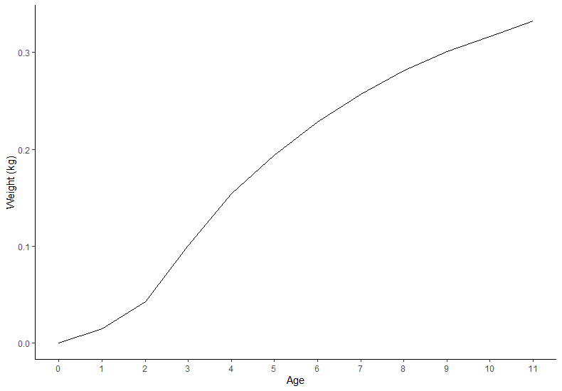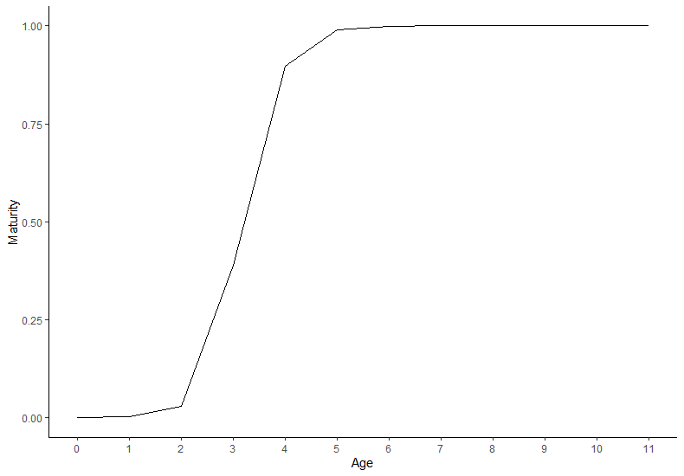 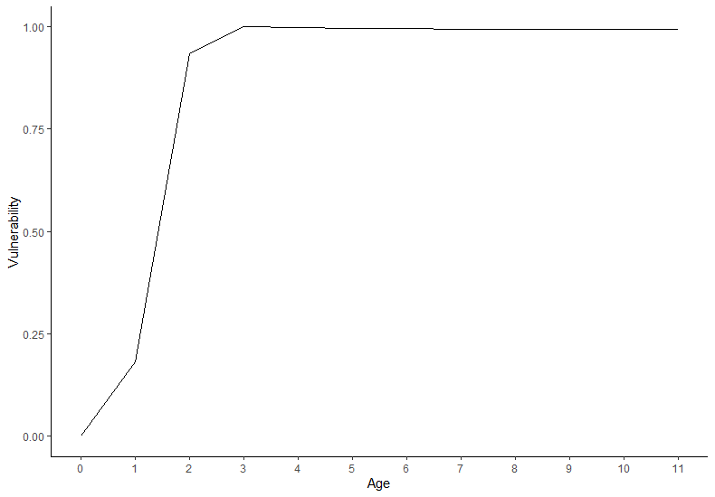

**Figure 1. Mean Weight-at-age, Maturity-at-age, and Vulneranility-at-age**

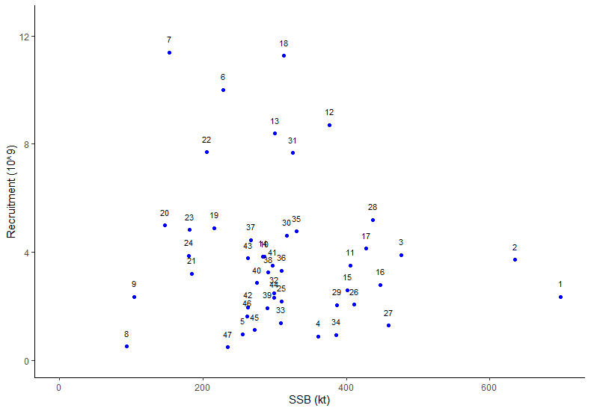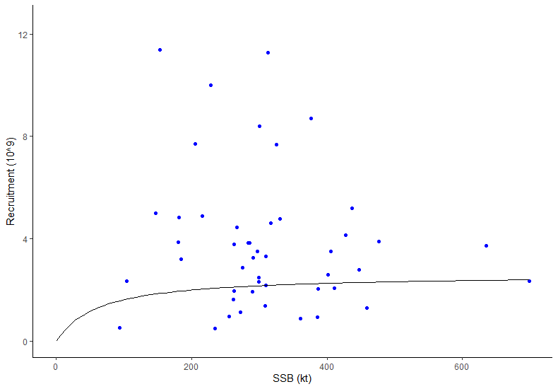

**Figure 2. Estimated Stock Recruitment Pairs (left panel: data labels are years; right panel: Model Estimated Fit)**

*Note: Model estimated Beverton-Holt stock recruitment relationship, a = 0.04301038; b = 0.01645661, estimated from assumed h = 0.75*

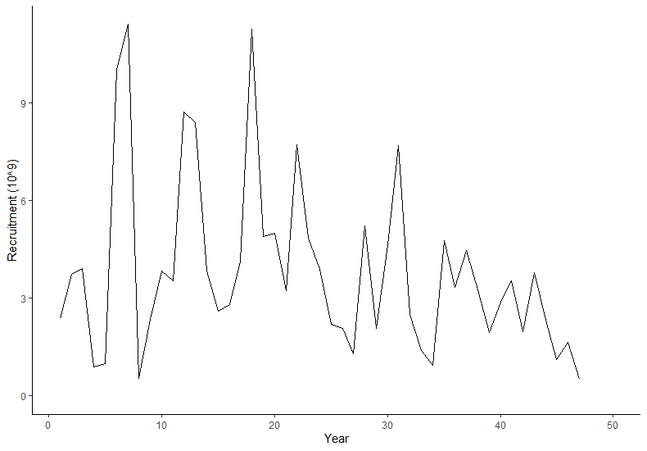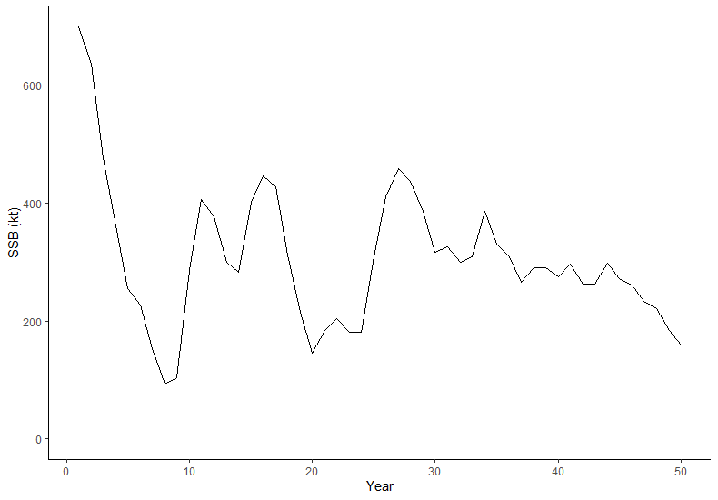 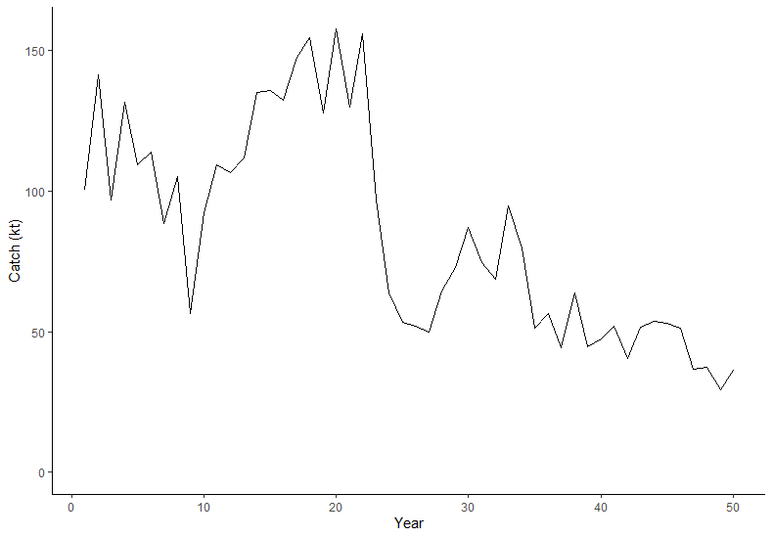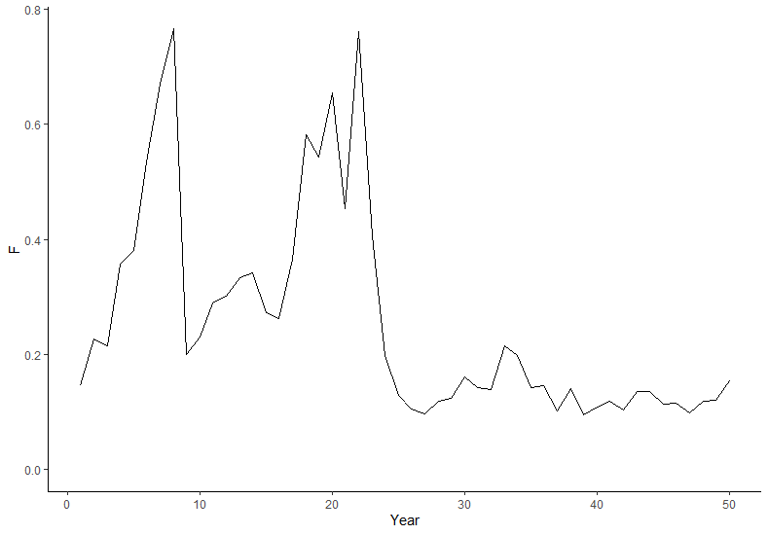

**Figure 4. Time Series Plots for Model Estimated Recruitment, Model Estimated Spawning Stock Biomass, Total Catch, and Model Estimated *F* (maximum *F*-at-age)**

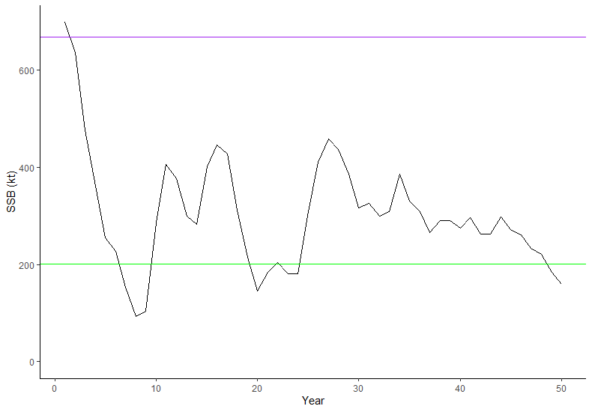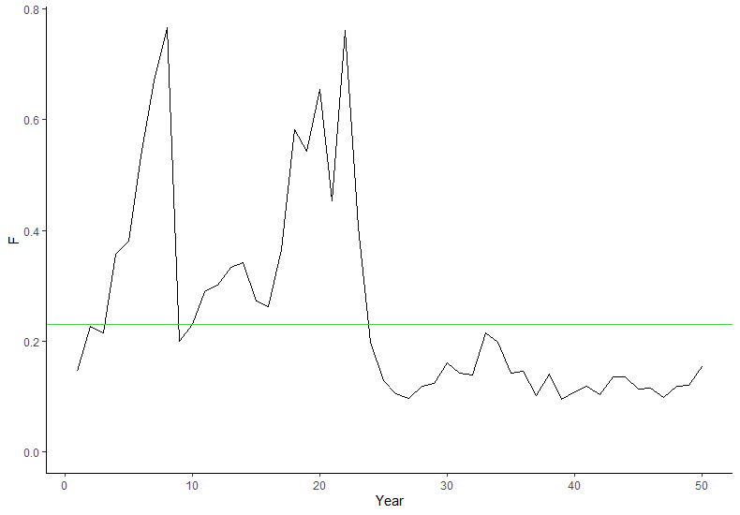

**Figure 4. SSB and *F* Time Series Plots**

*Notes: Purple line =**equilibrium SSB0, green line = equilibrium SSBMSY (left plot)or equilibrium FMSY (right plot)*

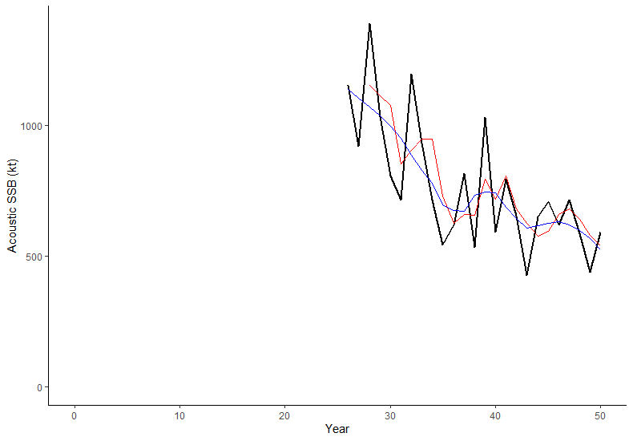

**Figure 5. Acoustic Index of SSB for MU1 (years 26-50)**

*Notes: Index is a relative index of SSB*

*Black line = Annual index, Red line = 3 year moving average, Blue line = loess smoother with span = 0.5*

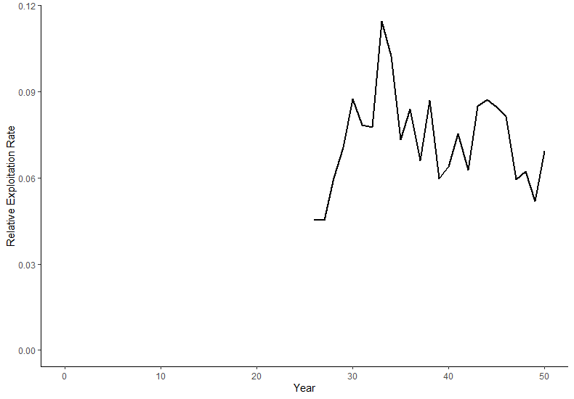

**Figure 6. Relative Exploitation Rate (years 26-50)**

*Notes: Calcualted as the ratio of Catch to the loess smoothed acoustic index of SSB*